
PRESS RELEASE Prague, 3 April 2019

Building A in BB Centrum gets an “A” again following reconstruction

The office Building A in Prague’s BB Centrum underwent overall renovations of the outer shell and interior spaces last year. The reconstruction of the building, with a total leasable space of 21 600 m², took place in cooperation with its exclusive tenant, the leading Czech bank, MONETA Money Bank, whose central office is located in Building A. The sensitive and effective renovations were designed by the A8000 architecture atelier. The owner of the building is the investment and development company PASSERINVEST GROUP, which is continuously developing the BB Centrum complex as a responsible urban investor, modernising the existing buildings so that they constantly offer first-rate services. At the same time, it is improving the quality of the urban environment by building parks, playgrounds and places meant for sports and relaxation. The overall investment into the reconstruction of Building A was in the amount of CZK 500 million.

The most striking change is the modification of the façade: the original plaster was replaced by smooth metal plates in a white colour, while the overhanging steel construction facing Vyskočilova Street is underscored by turquoise paint. Now a rooftop garden with an area of 1400 m² has been built on the roof on the 7th storey and includes gazebos, mature greenery and relaxation zones, with other green areas in the glass atriums on the ground floor. The reconstruction of Building A took place from April 2017 to October 2018.

The purity and simplicity of the building layout was preserved, just like the glass top of the atrium, which allows natural light to permeate through the entire building. The building is newly equipped with six elevators with intelligent destination management and an aquatherm black planar radiant ceiling system is used for heating and cooling. The original reception desk in the shape of a white amoeba was replaced on the tenant’s request, so that the shape and colour combination correspond to the MONETA Money Bank branch.

During the reconstruction of Building A, the repair of the adjacent pavements was carried out and a pedestrian crossing over Vyskočilova Street and a new bay for the bus stop was built. MONETA Money Bank also has a branch with ATMs on the ground floor of its headquarters and a self-service Perfect Canteen has opened for the public.

“We built Building A in 2002 as the third project of the nascent BB Centrum complex. It served its purpose for 16 years, though the technology and trends change, and so it was necessary to invest in more extensive repairs. We want to permanently maintain the high standard of BB Centrum, and not only by the scope of the offered services, but also by keeping the first-rate quality of the previously built office buildings,” stated Radim Passer, the founder and General Director of Passerinvest Group, with regard to the reconstruction.

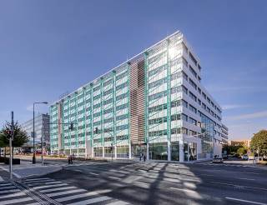

The reconstructed Building A in Prague’s BB Centrum

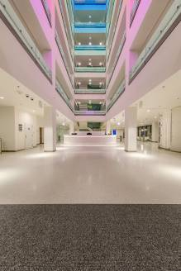

The new lobby of Building A in BB Centrum in Prague 4

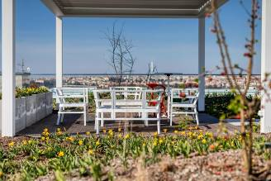

The new rooftop terrace of Building A in BB Centre

You can get more information and photographs in print quality from:
Kristýna Samková, Head of PR and Marketing Department
PASSERINVEST GROUP, a.s.
Tel.: (+420) 221 582 111
E-mail: Kristyna.Samkova@Passerinvest.cz
www.passerinvest.cz, www.bbcentrum.cz

Marcela Štefcová
Crest Communications a.s.
Mobil: (+420) 731 613 669
E-mail: marcela.stefcova@crestcom.cz

About the company

PASSERINVEST GROUP, a. s., is a purely Czech development and investment company, whose name is primarily connected with the construction of the BB Centrum complex in Prague 4 – Michle. The company, established by Radim Passer in 1991, has built a very good reputation both on a local and international level with this, the most successful and extensive project of its kind in Central Europe. This is not only to the credit of the quality of the implemented projects and the high level of the provided services, but also due to the sense of fair play, an accommodating relationship with the buildings’ tenants/users and responsibility to the society and the environment. PASSERINVEST GROUP also has other interesting investment and development projects in its portfolio, as well as projects that serve the general public and the citizens of Prague.

